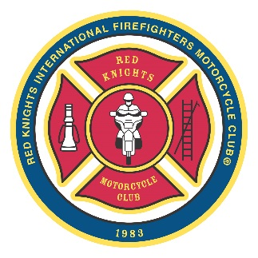
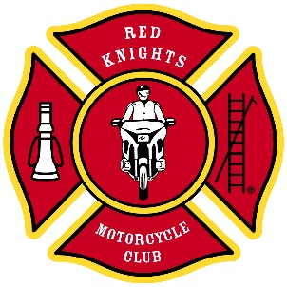
®

Red Knights International Firefighters Motorcycle Club® Inc.

Office of the Region 2 Director

M.R. (Randy) Smith

8 Rosswood Crescent

Toronto, Ontario, Canada, M1P 3N2

1-647-470-7562 (RKMC)

region2@redknightsmc.com

®

Red Knights International Firefighters Motorcycle Club® Inc.

Office of the Region 2 Director

M.R. (Randy) Smith

8 Rosswood Crescent

Toronto, Ontario, Canada, M1P 3N2

1-647-470-7562

region2@redknightsmc.com

2025 End of Year Report from Region 2

Greetings/Felicitations!

It is a pleasure to give the membership an update from Eastern Canada. This report covers my activities in 2025. First, a brief look at Region 2.

Our Region encompasses all 6 of the provinces from Ontario to Newfoundland. We currently have 40 chapters, and approximately 894 chapter members and 19 M-A-Ls. It’s a large geographic area, with Canada’s most and least populated provinces. It’s beautiful riding from one end to another.

The Year in Review

This year has been a busy time for yours truly. As well as meeting with firefighters interested in joining/starting chapters, answering questions from throughout the Region, and attending my own chapter meetings, bike nights, etc, here are some of the other events I attended. All in all, my mileage for 2025 is in the 16,000 km range.

This year, I attended the following functions as the Region 2 Director. Events in Bold are detailed below.

- The International Motorcycle Supershow in Toronto in January. The largest show of it’s type in Canada is a great opportunity to showcase our Club. We are here every year.
- The Camp Bucko Bonspiel in February, where the Red Knights sponsor a sheet of ice to support Ontario's premier summer camp for children recovering from burns.
- Two Red Knights funerals in NY state, (February, March) where the families were presented with Heaven One honours (more on that below)
- Met with visiting Red Knights from Germany, where we showed them our station.
- In April, and November, I travelled to Baltimore MD, for RKMC International Board meetings. These are in-person sessions where we carry on the business of the Club.
- The Board also met by Zoom several times throughout the year, to handle other issues that arise.
The Atlantic Rally in Bouctouche, NB. Once again, a great rally, and as always, great hospitality from our Brothers and Sisters down East. In 2026, it's in Truro, NS from July 30 to August 02. Get your chapter together and show your support for a Canadian home-grown good time!
- The Central Ontario Ride For Sight.

Camp Bucko Ride Ontario 1, with other chapters, provide a motorcycle escort for busloads of campers to Camp Bucko (Ontario’s premier summer camp for burn victims) each year. These are children who need a safe, inclusive place for a summer camp. This is now a “must” ride for Ontario members.
The RKMC International Convention in Peoria, IL. (To really appreciate this Club, you have to attend at least one convention. Once you do, you'll be back - guaranteed.) This year, there were some great rides, and lots of great times.
Went to Niagara Falls to meet with Red Knights from Australia. (Thanks to Ontario 12 for hosting).
The Canadian Fallen Firefighters Memorial Weekend, in Ottawa. In 2024, we had 5 Red Knights and a special duty with the families of the fallen. This year there were 13 of us! In 2026 it will be September 11-13. We really want each province represented. There are tears at times, it's a solemn occasion, but there is a great weekend of fellowship waiting for you. If you are within riding distance, you need to be there. Many of the Red Knights travel between 5 - 14 hours to honour our fallen. You have 9 months to plan this weekend. Do it.

The 2026 RKMC International Convention will be in Melbourne, Australia from August 19 - 23. Yes, it's a long way, but when are you ever going to get this chance? Riding in Australia with your RKMC family, petting koalas, fighting off crocodiles (oops, forget that part). A once in a lifetime opportunity. Just do it!

My schedule for next year includes - England/UK Meetup (Essex, UK) in May, Western Rally (High River, Alberta) in June, Atlantic Rally (Truro, NS) in July, the International Convention (Melbourne, Australia) in August, CFFF Memorial (Ottawa, ON) in September. The more you involve yourself in this Club, the more you get out of it.

What is Heaven One? When a Red Knights member in good standing passes away, they are entitled to special honours from the Club. This includes a flag and coin presentation, and their name engraved at the Memorial House in Boylston, Mass. Chapters must notify the International for these honours to be granted. Rosters must be up to date, and dues paid. By the way, did you know that you can stay at the Memorial House for a small donation?

This Club gets better when we get together. If your chapter is holding a ride, fundraiser or social, let me help get the word out. I cannot tell you the number of times that I get contacted with "We just found out that chapter "x" had an event and never told us." Invite me to your meeting, and have your members meet their Regional Director. Communication is key!

New Brunswick, Nova Scotia, PEI and Newfoundland - We now have Provincial reps from each province. Thanks to those members who stepped up. It’s much appreciated.

In 2025, some new chapters were formed, and others ceased operations. Usually a chapter closes due to not bringing in new members. Even one new member can make a difference.

I am happy to answer each email and phone call that I receive. If I don’t get back to you right away, I apologize but I’ll do my best. I’m happy to explain a procedure or SOG, and have the other person understand the real meaning of it. We on the Board are constantly looking for ways to improve communication and clarify terms that aren’t common language to everyone.

The coming year is already off to a busy start. The Spring International Board meetings are set, and we have Zoom meetings on a continuous basis. Everyone is looking forward to this year’s Convention in Australia. My home chapter is already well into planning for the 2027 Convention at sea, sailing from Florida and hosted by Ontario 1.

Please know that I am always available to chat, unless I’m running calls at work. Phone, email or drop by the fire station (with a little notice!) and I’ll put the coffee on. Here’s to a great 2026 with lots of riding, and lots of memories.

I remain,

Loyal To Our Duty

Randy Smith

Region 2 Director

647-470-7562 (RKMC)

